# Data Challenge

The goal is to identify potential fraudulent or money laundering suspicious cases in the dataset. The data doesn’t contain any labels from the client hence the only way to identify suspicion is finding out what is normal and what can be considered an anomaly and hence potentially suspicious.

## Data description:

The attached file contains transactional data from businesses. Customers pay at those businesses (credits to the business) and businesses refund money to customers (debits from the business).

The holding party of a transaction references the business while the counter party references the customer.

## Data Fields:

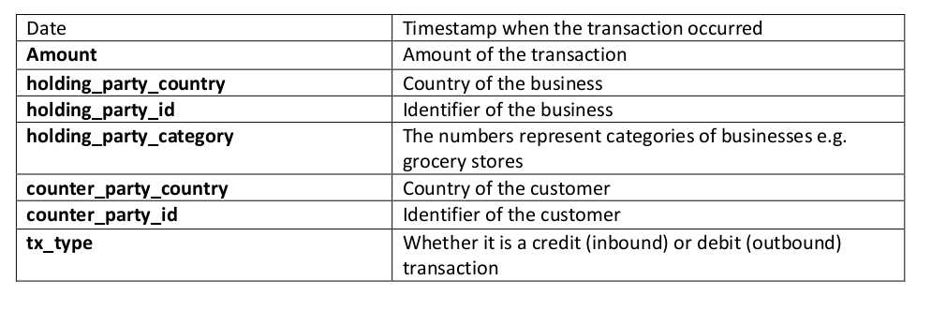

## Objectives:

* Identify businesses which behavior can be considered abnormal.
* Identify anomalous transactions within the businesses.
* Provide a way of obtaining explanations for the identified anomalous transactions and businesses in a human understandable way.

## Deliverables:

* Prepare a Jupyter Notebook with the applied machine learning and/or deep learning methods.
* Please summarize your key results/findings in a very short presentation.
* Describe in short what other things you would do if you had more time and need to dig deeper (as part of the presentation).
* Imagine you have in addition the reference text of the transaction available. How could you analyze this field?